**Practical no: 5**

**1.Point Detection**

%Dnyaneshwari Jyprakash Ekhamde

%Roll No. 31132

f = imread("C:\Users\kulso\Desktop\cameraman.png") f=rgb2gray(f);

w=[-1,-1,-1;-1,8,-1;-1,-1,-1]; g=abs(imfilter(double(f),w));

T=max(g(:)); g=g>=T; figure(1); subplot(121); imshow(f), title('Original Image'); subplot(122); imshow(g),

title('Result of Point Image');

**Output:**

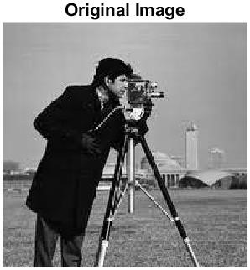 

**3. Edge Detection**

%Dnyaneshwari Jyprakash Ekhamde

%Roll No. 31132

image4_1 = imread("C:\Users\kulso\Desktop\cameraman.png"); image4_1 = rgb2gray(image4_1); mask4 = [-1 -1 -1; -1 8 -1; -1 -1 -1];

image5 = conv2(double(image4_1), double(mask4), 'same'); image5_1 = uint8(image5);

image5_1 = imresize(image5_1, [111, 75]);

% Ensure the dimensions of image5_1 match with image4_1 image5_1 = imresize(image5_1, size(image4_1)); image7 = imadd(image4_1, image5_1); figure; subplot(2, 2, 1); imshow(image4_1); title('Original Image'); subplot(2, 2, 2); imshow(image5_1);

title('Applying Laplacian Filter'); subplot(2, 2, 3); imshow(image7);

title('Adding Sharpened image to original image');

**Output:**

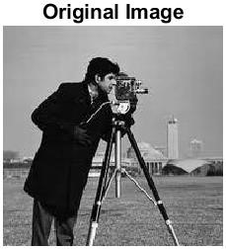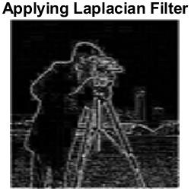

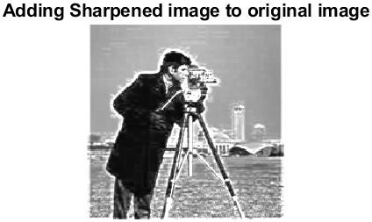

2.Line Detection

%Dnyaneshwari Jyprakash Ekhamde

%Roll No. 31132

imo = rgb2gray(imread("C:\Users\kulso\Desktop\line.png"));

se = strel('line',17,5);

sim = imdilate(imo, se);

se2 = strel('disk', 1);

sim = imdilate(sim, se2);

sim = bwareaopen(sim,350);

sim=bwmorph(sim, 'skel', inf);

figure

subplot(1,2,1);

imshow(imo)

title('Original Image');

subplot(1,2,2);

imshow(sim)

title('Line Detection Image');

OUTPUT

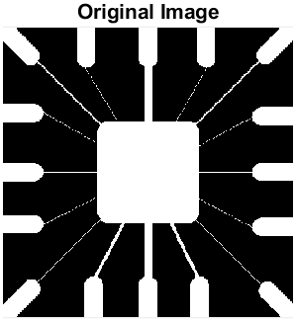 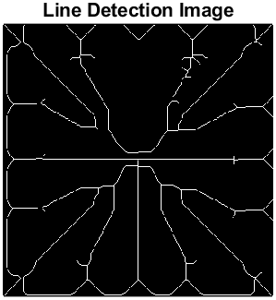

4.Thresholding

%Dnyaneshwari Jyprakash Ekhamde

%Roll No. 31132

load trees

BW = im2bw(X,map,0.4);

imshow(X,map), figure, imshow(BW)

